Allyson Pascua

Assignment 1215

**Sierpinski Gasket Dream App**

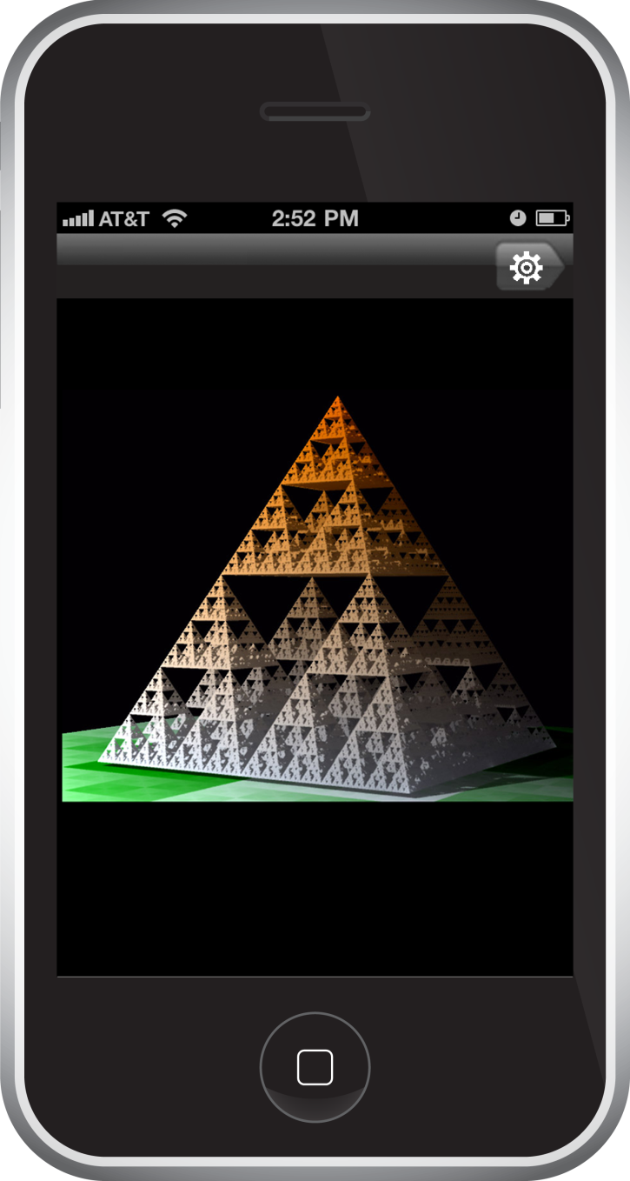The app consists of two views: *main* and *settings*.

The *settings* view consists of two subviews: *color, subdivisions*.

The main view displays the Sierpinski triangle in full view. The navigation bar in this view has one arrow-shaped button pointing to the right. This button leads to the settings view. It is represented with an icon of a gear. The gear was chosen since it has become universally associated with settings. A text label for the settings button was avoided to provide a cleaner and simpler look to the interface. It was also avoided to provide uniformity to the navigation bar design, as will be seen in the *settings* view.

In the main view, the user is provided the options to translate, rotate, and scale (zoom) the Sierpinski triangle via multi-touch gestures. A table of these gestures can be found on the next page.

**Sierpinski Multi-Touch Gestures**

|  |  |  |
| --- | --- | --- |
| Translation | 1-finger swipe in desired direction of translation |  |
| Rotation (x-axis) | 2-finger vertical swipe |  |
| Rotation (y-axis) | 2-finger horizontal swipe |  |
| Rotation (z-axis) | 2-finger clockwise/counterclockwise motion |  |
| Scaling | 2-finger pinch (outwards to scale up/zoom in and inwards to scale down/zoom out) |  |

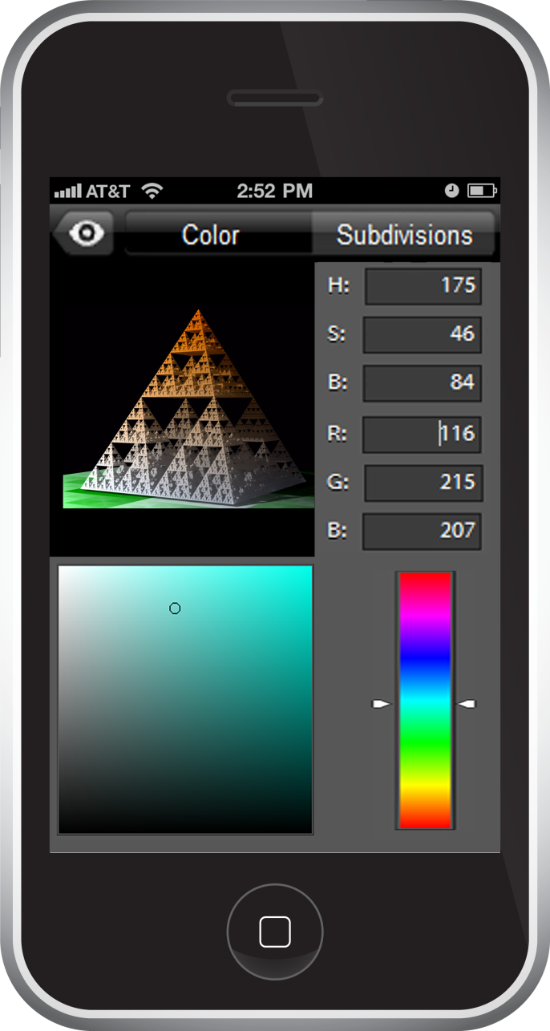 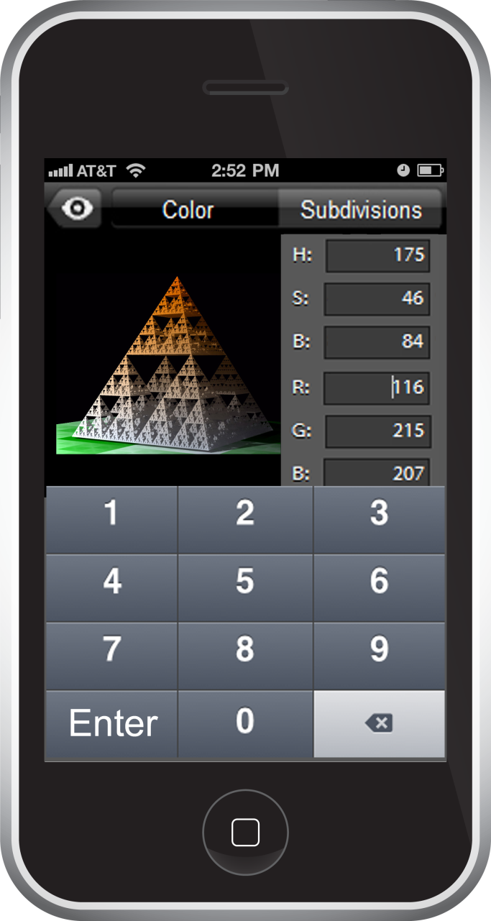

When the user taps the settings button in the navigation bar, the user is taken to the settings view. When the settings view is launched, the navigation bar updates. The settings button is no longer in view. Now, the navigation bar contains one icon button and two tabs. On the top left is the view button, which is represented with an eye icon. This arrow-shaped button points left to indicate that it returns the user to the main view.

The left tab is labeled “Color”. This brings the user to the *Color* subview, where the user may change the color of the Sierpinski triangle. This view is divided into four sections. The top left section contains a view of the Sierpinski triangle, essentially a miniaturized version of the one in the main view. This view dynamically updates the color of the triangle as the user alters the color values. The bottom left and right sections contain a square color palette and color slider. The color palette contains a small circular indicator to display the current selection. The user may slide the indicator around the color palette to alter the RGB values, the saturation, and brightness. The color slider is flanked by two arrows that point to the current selection. The user may slide the indicator on the color slider to alter the hue.

The top right sections provides a numerical way for the user to alter all the color values. These text fields are wider than necessary to make it easier for the user to select the desired field. Each field is labeled with its corresponding quality. When the user taps on any of the text fields, a numeric keypad will slide in from the bottom of the screen. In addition to the ten buttons for each digit from 0 to 9, there are two additional buttons. The bottom left button on the numeric keypad allows the user to enter their input. This is labeled with the text “Enter”. The bottom right button on the numeric keypad serves as a “backspace” button to erase previous input. The backspace button occupies the bottom right space for consistency with the standard iOS numeric keypad. Changing the color through any of these components automatically updates values/statuses of the other components (For example, if the the user changes slides the color slider, the hue text field value updates).

The right tab is labeled “Subdivisions”. Tapping this brings the user to the *Subdivisions* subview, where the user may change the depth of the triangle (number of subdivisions of triangles).

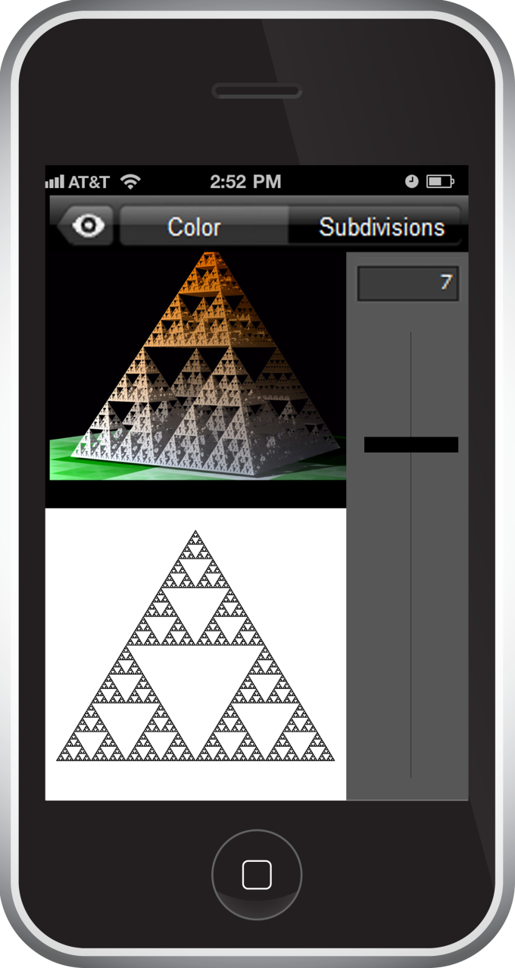 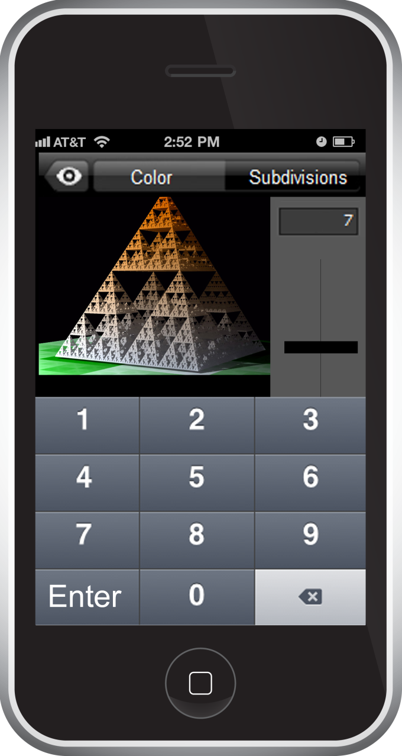

The Subdivisions view is divided into three sections. The top left section contains a view of the Sierpinski triangle, essentially a miniaturized version of the one in the main view. The bottom left section contains a two dimensional view of the Sierpinski triangle. Both views dynamically update as the user alters the number of subdivisions of triangles. The right side contains a text field and a slider. Both components alter the number of subdivisions. Sliding the subdivision slider up increases the subdivision count and sliding the slider down decreases the subdivision count. The user may numerically alter the subdivision count through the subdivision text field. When the user taps on the subdivision text field, a numeric keypad will slide in from the bottom of the screen (the same keypad described in the color view). Changing the number of subdivisions through any of these components automatically updates the values/statuses of the other components (For example, if the user changes slides the subdivision slider, the subdivision text field value updates). ulti-Touch Gesturesgestures can be found on the next page.igation button taken to the zes r e settings view.vide a cleaner and